PyPlanscoring Technical Note

Generating reports on XiO version less than 5.00

# Abstract:

The Manufacturer (0008,0070) is reported as CMS, Inc. . The CT images are derived from incoming original images and are not original copies; the Image Type (0008,0008)

will be reported as ORIGINAL\SECONDARY\AXIAL.

As of the XiO 5.00 release, the default export behavior for XiO is to export DICOM data

in the original CT images frame of reference (“Original DICOM” coordinate).

If necessary, a user with administrator rights can set the export frame of reference back to

the pre-XiO 5.00 type where the CT data is in a patient relative coordinate system but

may not have the same origin as the original images. In this “ XiO Generated” coordinate

mode, the images will always be set to Head First (even if the plan is Feet First) and this

“XiO Generated” coordinate will have a new frame-of-reference UID.

Then, a plan exported using pre-XiO 5.00 uses “XiO Generated” corrdinate system that is different from “Original DICOM” coordinate.

**Generating reports on XiO less than 5.00**

**Ex. Participant folder containing only one RP/RS/RD files that were exported using XiO.**

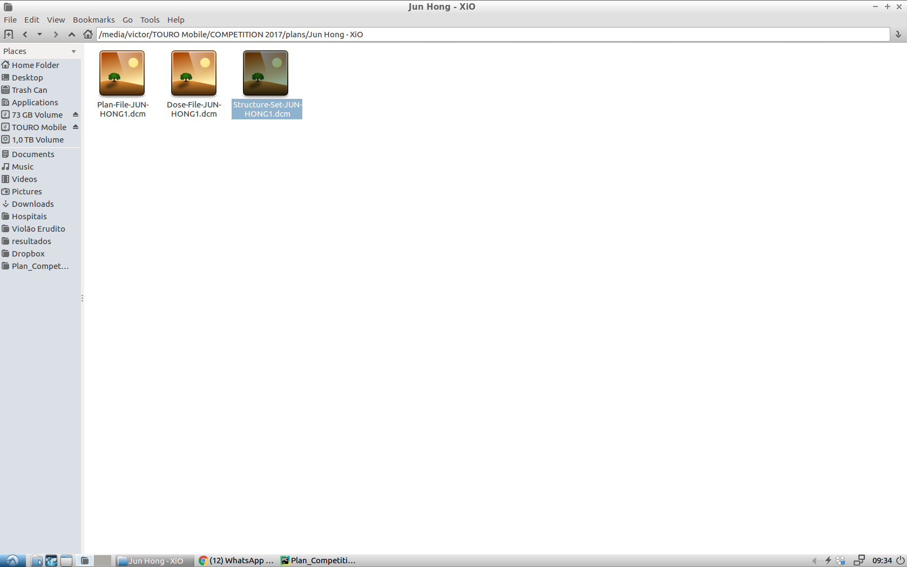

Step 1 – Change **PyPlanScoring.ini** file before run the app.

Set use_tps_structures = yes

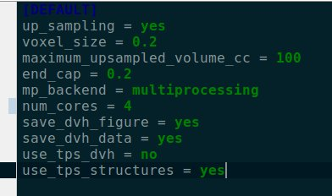

Then, PyPlanScoring will use the RS file inside participant’s folder to calculate the DVH.

Step 2 – Run PyPlanScoring

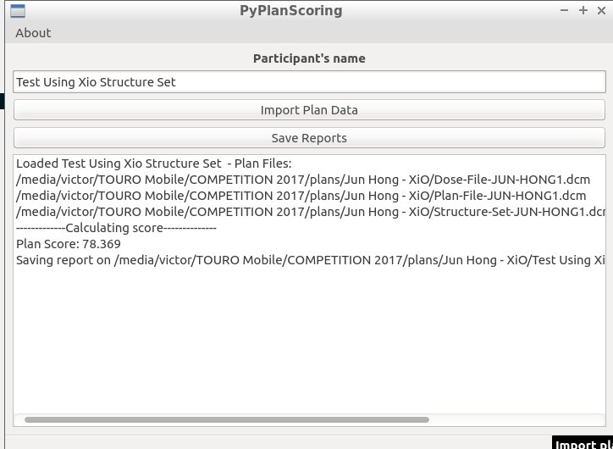

Step 3 – The result.

